# Using Background Processing to Build Scalable Applications with Hangfire

## Lab 1

### Goal

The goal of this exercise is to ensure that base solution for this workshop can be opened in Visual Studio and that it both builds and runs in your environment. This solution represents our base application which experiences performance issues as our Lemmings are scheduled to do work.

## Steps

1. Open your browser, and navigate to <https://github.com/dbuckingham/CPL16-Hangfire>.
2. Find the “Download ZIP” button, click, and save the zip file on your local machine.
3. Extract the zip file to a folder on your local machine. Note: it may be necessary to Unblock the zip file. Right-click on the zip file, select Properties, check the Unblock checkbox, and click OK.
4. Using Visual Studio 2015, open the LemmingSchedulingSystem.sln solution file, located in the CPL16-Hangfire\src\LemmingSchedulingSystem folder.

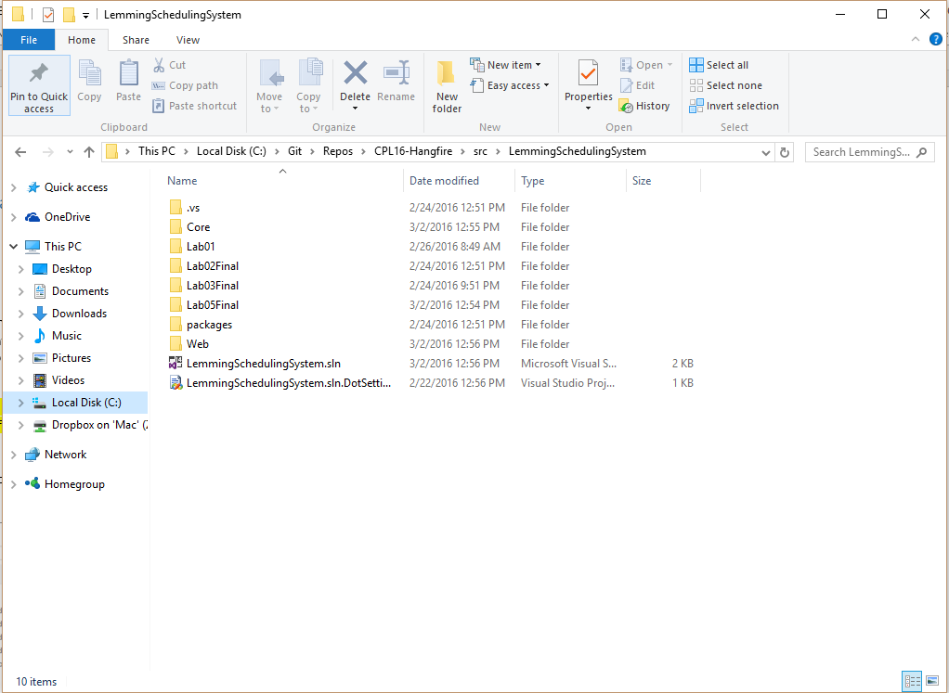

1. Create the LEmmingSchedulingSystem database by opening the Package Manager Console from Visual Studio (Tools \ NuGet Package Manager \ Package Manager Console) and typing the following command:

PM> Update-Database -ProjectName Core

1. Once the LemmingSchedulingSystem solution is open, press F5 to Start Debugging. You should see the LEmming Scheduling System open in your browser.

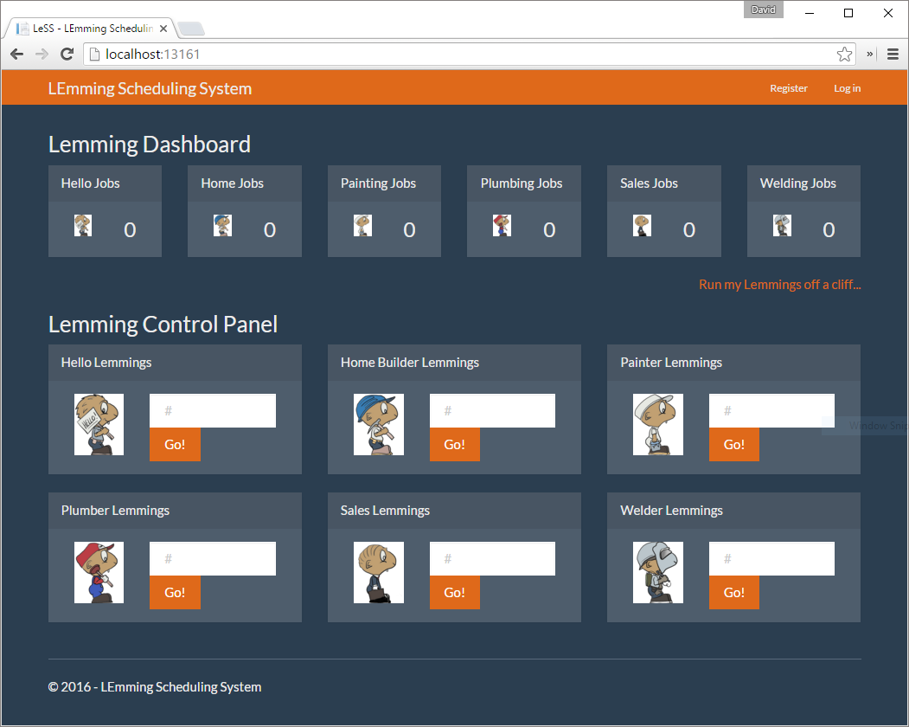

You will notice that the LEmming Scheduling System is divided into two areas: the Lemming Dashboard and the Lemming Control Panel.

The Lemming Dashboard displays the amount of work that has been completed, by each type of Lemming.

The Lemming Control Panel allows the user to select the amount of work to be performed.

Before we start to use the LEmming Scheduling System, let’s open the browser’s Developer Tools. To do so, press the F12 button, and select the Network tab in the Developer Tools panel. This will allow us to monitor the performance of our Lemmings.

1. Let’s schedule 10 Lemmings to Say Hello. To do so, enter the value 10 in the Say Hello widget, and click the Go button.

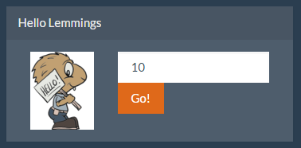

1. Observe the POST request to DoSayHelloJob. Our Lemmings complete work in sequence to complete their jobs.



NOTE: Your timings may vary as our Lemmings simulate work.

You’ll notice in the screenshot above that our POST to DoSayHelloJob took nearly 53 seconds to complete. During this time our application was blocked and no other Lemmings could be scheduled to work.

1. Once our Lemmings have completed their jobs, notice the statistics on the Lemming Dashboard:

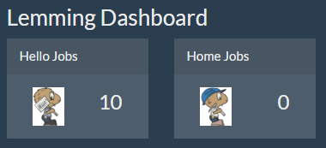

1. To reset your statistics, click the “Run my Lemmings off a cliff…” link.

This completes Lab 01.